

Faculty of Engineering and Technology Electrical and Computer Engineering Department

Communication laboratory ENEE4113

Report #3

Exp#10: Amplitude Shift Keying (ASK)

Prepared by:

Arwa Doha – 1190324

Instructor: Dr.Ashraf Rimawi

Assistant: Eng.Mohammed Battat

Section: 6

Date: January 17, 2024

**Abstract**

The The aim of this experiment is to understand the concept of Amplitude Shift Keying (ASK) modulation in both its time and frequency domains. This exploration delves into two keying methods, hard and soft keying, and analyzes the impact of modulation index on the frequency spectrum. By revealing how modulation influences the signal's frequency components, the experiment provides valuable insights into ASK techniques, keying methods, and modulation indices. These insights contribute to a comprehensive understanding of ASK and its critical role in digital communication systems.



**Table of contents**

Table of Figures iii

1. Theory 1
   1. **Amplitude Modulation Techniques in Digital-Communication……………………………………..1**
   2. Amplitude sheft keying 1
      1. ASK Modulator 2
      2. ASK DeModulator 5
2. Procedure and data analysis 5
   1. Part One: Amplitude shift keying Modulation (Time domain) 5
      1. Hard keying 5
      2. Soft keying 7
      3. Detecting the comparator threshold 9
   2. Part Two: Amplitude shift keying Modulation (Frequency domain) 11
      1. Hard keying 11
      2. Soft keyin 12
      3. Studying the effect of changing the message signal amplitude (Time and frequency domains) 13
      4. Studying the effect of changing the message signal frequency on (Time and frequency domains) 15
      5. Studying the effect of changing the message signal duty cycle (Time and frequency domains) 19
   3. Part Three: Part 3: Amplitude shift keying Demodulation (Time and frequency domains) 23
      1. Hard keying 24
      2. Soft keying 26
      3. Studying the effect of changing the message signal frequency on the demodulation 28
      4. Studying the effect of changing the message signal duty cycle on the demodulation 32
3. Conclusion 42
4. References 43

# Table of Figures

Figure1.1. 1 Hard keying ASK circuit 1

Figure1.1. 2 ASK Circuit diagram 2

Figure1.1. 3 ASK modulated signal 2

Figure1.1. 4 ASK modulated Block diagram 3

Figure1.1. 5 Waveform of ASK modulated 3

Figure1.1. 6 Waveform of ASK Demodulated 4

Figure2.1. 1 Hard keying ASK circuit 9

Figure2.1. 2 Time-Domain Waveforms of Hard-Keyed ASK modulaton Signal with 100% Modulation Index 10

Figure2.1. 3 Time-Domain Waveforms of Hard-Keyed ASK Modulated Signal at TXOUT(A11) 10

Figure2.1. 4 ASK Modulated Signal with Hard Keying (m = 50%) 10

Figure2.1. 5 Soft keying ASK circuit 12

Figure2.1. 6 Soft-Keyed ASK modulaton Signal with 100% Modulation Index 12

Figure2.1. 7 Soft-Keyed ASK modulaton Signal with 50% Modulation Index 14

Figure2.1. 8 Low-Level Appearance in ASK Signal at Lower Threshold 14

Figure2.1. 9 High-Level Appearance in ASK Signal at Upper Threshold 15

Figure2.2. 1 Hard-Keyed ASK Spectrum with m=100% (FFT Analysis) 16

Figure2.2. 2 Hard-Keyed ASK Spectrum with m=50% (FFT Analysis) 16

Figure2.2. 3 Soft-Keyed ASK Spectrum with m=100% (FFT Analysis) 17

Figure2.2. 4 Soft-Keyed ASK Spectrum with m=50% (FFT Analysis) 17

Figure2.2. 5 Time-Domain Impact of Message Amplitude Reduction on ASK(A11&A12) 18

Figure2.2. 6 Freq-Domain Impact of Message Amplitude Reduction on ASK(A11&A12) 19

Figure2.2. 7 Time-Domain Impact of Message Amplitude Reduction on ASK(A21&A22) 19

Figure2.2. 8 Freq-Domain Impact of Message Amplitude on ASK(A21/A22) 20

Figure2.2. 9 Time-Domain Impact of Message frequency on ASK(A11) 20

Figure2.2. 10 Freq-Domain Impact of Message frequency on ASK(A11) 21

Figure2.2. 11 Time-Domain Impact of Message frequency on ASK(A12) 22

Figure2.2. 12 Freq-Domain Impact of Message frequency on ASK(A12) 22

Figure2.2. 13 Time-Domain Impact of Message frequency on ASK(A21) 23

Figure2.2. 14 Freq-Domain Impact of Message frequency on ASK(A21) 24

Figure2.2. 15 Time-Domain Impact of Message frequency on ASK(A22) 25

Figure2.2. 16 Freq-Domain Impact of Message frequency on ASK(A22) 25

Figure2.2. 17 Time-Domain Impact of Message duty-cycle on ASK(A11) 27

Figure2.2. 18 Freq-Domain Impact of Message duty-cycle on ASK(A11) 27

Figure2.2. 19 Time-Domain Impact of Message duty-cycle on ASK(A12) 28

Figure2.2. 20 Freq-Domain Impact of Message duty-cycle on ASK(A12) 28

Figure2.2. 21 Time-Domain Impact of Message duty-cycle on ASK(A21) 27

Figure2.2. 22 Freq-Domain Impact of Message duty-cycle on ASK(A21) 27

Figure2. 23 Time-Domain Impact of Message duty-cycle on ASK(A22) 28

Figure2.2. 24 Freq-Domain Impact of Message duty-cycle on ASK(A22) 28

Figure2.3. 1 ASK Demodulation circuit……………………………………………………………………….23

Figure2.3. 2 ASK DeModulated Signal with Hard Keying (m = 100%)(Time-Domain)…………………………24

Figure2.3. 3 ASK DeModulated Signal with Hard Keying (m = 100%)(Freq-Domain)…………………………24

Figure2.3. 4 ASK DeModulated Signal with Hard Keying (m = 50%)(Time-Domain)…………………………..25

Figure2.3. 5 ASK DeModulated Signal with Hard Keying (m = 50%)(freq-Domain)……………………………25

Figure2.3. 6 ASK DeModulated Signal with Soft-Keying (m = 100%)(Time-Domain)…………………………26

Figure2.3. 7 ASK DeModulated Signal with Soft-Keying (m = 100%)(Freq-Domain)…………………………..26

Figure2.3. 8 ASK DeModulated Signal with Soft-Keying (m = 50%)(Time-Domain)…………………………..27

Figure2.3. 9 ASK DeModulated Signal with Soft-Keying (m = 50%)(freq-Domain)……………………………27

Figure2.3. 10 Time-Domain Impact of Message frequency on Demodulation ASK(A11)……………………..28

Figure2.3. 11 Freq-Domain Impact of Message frequency on Demodulation ASK(A11)……………………...28

Figure2.3. 12 Time-Domain Impact of Message frequency on Demodulation ASK(A12)……………………..29

Figure2.3. 13 Freq-Domain Impact of Message frequency on Demodulation ASK(A12)………………………29

Figure2.3. 14 Time-Domain Impact of Message frequency on Demodulation ASK(A21)……………………...30

Figure2.3. 15 Freq-Domain Impact of Message frequency on Demodulation ASK(A21)………………………30

Figure2.3. 16 Time-Domain Impact of Message frequency on Demodulation ASK(A22)……………………..31

Figure2.3. 17 Freq-Domain Impact of Message frequency on Demodulation ASK(A22)……………………...31

Figure2.3. 18 Time-Domain Impact of Message duty-cycle on Demodulation ASK(A11)……………………..33

Figure2.3. 19 Freq-Domain Impact of Message duty-cycle on Demodulation ASK(A11)……………………...33

Figure2.3. 20 Time-Domain Impact of Message duty-cycle on Demodulation ASK(A12)……………………..34

Figure2.3. 21 Freq-Domain Impact of Message duty-cycle on Demodulation ASK(A12)……………………..34

Figure2.3. 22 Time-Domain Impact of Message duty-cycle on Demodulation ASK(A21)……………………..35

Figure2.3. 23 Freq-Domain Impact of Message duty-cycle on Demodulation ASK(A21)……………………..35

Figure2.3. 24 Time-Domain Impact of Message duty-cycle on Demodulation ASK(A22)……………………..36

Figure2.3. 25 Freq-Domain Impact of Message frequency on Demodulation ASK(A22)………………………36

# Theory

## Amplitude Modulation Techniques in Digital-Communication

In the world of digital-communication, there are different ways to send data or messages through communication-channels. Amplitude Shift Keying (ASK) is one of these methods. It changes the height of a carrier signal to transmit information. ASK is a flexible modulation technique used in digital data transmission, television, and-radio.[1]

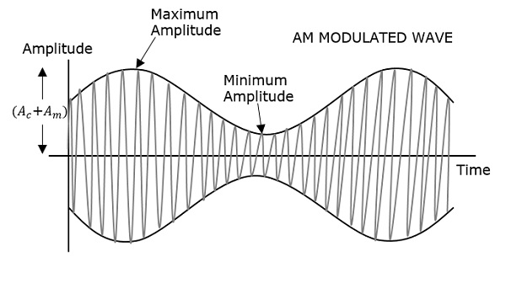

*Figure1.1. 1(Amplitude Modulation[2]*

## Amplitude Shift Keying

Amplitude-Shif-Keying (ASK) is a type of digital-modulation-method. It uses changes in the size of a carrier-signal to send digital information. In ASK, a big carrier signal represents a-binary '1,' while a small carrier-signal representsgagbinary '0.'

In this process, we combine a carrier.aand a digital message signal. The carrier-signal is usually a highgfrequency wave that acts as a carrier for the digitalhinformation. The binary messagegsignal, which is made up of '0's and '1's, determines how strong or weak the carrier-signal should be. After we put these signals together, we send thegresulting signal through the communicationhchannel.[1]

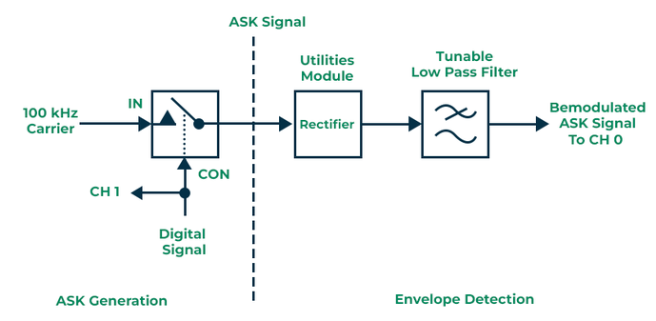

*Figure1.1. 2* *ASK Circuit diagram*

### ASK Modulator

The expression for an Amplitude Shift Keying (ASK) modulated signal is given by X_ASK(t) = i * cos(ωCt + φ0) for 0 ≤ t ≤ T, where the amplitude i can take M different values denoted by Ai. The angulargfrequency ωC andhphase φ0 are constant. Specifically, when M equals 2 (with A1=0 & A2=A,gwhere A is a constant), the resulting x_ASK(t) corresponds to a binary ASK modulated-signal. This form of ASK signal is designed to transmit binary-messages. When the modulating data is a logic high, the signal is considered "on," and when it is a logic low, it is considered "off." This modulation is commonly referred to as On-OffhKeying.[3]

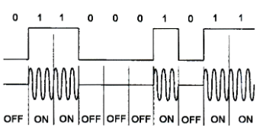

*Figure1.1. 3 ASK modulated signal*

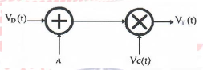

*Figure1.1. 4 ASK modulated Block diagram*

The variable A represents a DC bias, and the sinusoidal carrier-signal is given by 𝑉𝐶(𝑡) = 𝐴𝐶 cos(2𝜋𝑓𝑐𝑡), where 𝐴𝐶 is the amplitude and 𝑓𝑐 is the carrier frequency.

The modulating-signal 𝑉𝐷(𝑡) is binary data. The modulated-signal 𝑉𝑇(𝑡) can be formulated as 𝑉𝑇(𝑡) = [𝑉𝐷(𝑡) + 𝐴]𝐴𝐶 cos(2𝜋𝑓𝑐𝑡). The waveforms of 𝑉𝐷(𝑡), [𝑉𝐷(𝑡) + 𝐴], and 𝑉𝑇(𝑡).

It is evident that the Amplitude-Shift-Keying (ASK) modulated-signal 𝑉𝑇(𝑡) comprises two levels, [𝑉𝐷(𝑡)+𝑉𝐿]*𝐴𝐶, and [𝑉𝐷(𝑡) + 𝑉𝐻]*𝐴𝐶, corresponding to the low and high-states of the modulating-signal 𝑉𝐷(𝑡).[3]

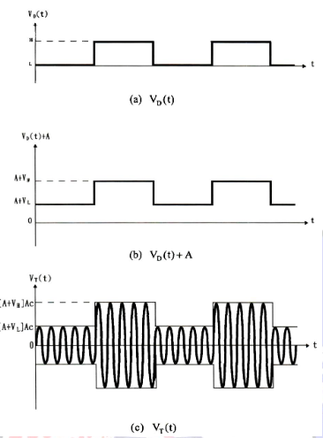

*Figure1.1. 5 Waveform of ASK modulated*

### ASK DeModulator

Demodulating ASKhsignals is the process of recovering the original digital-modulating signal from the received ASKgsignal. *Figure1.1. 6* demonstrates how ASK/demodulation works. The electronicGcircuitGresponsible for ASK demodulation is known as an-ASK demodulator. There are two-types of ASK demodulators: noncoherent-and-coherent demodulators.[3]

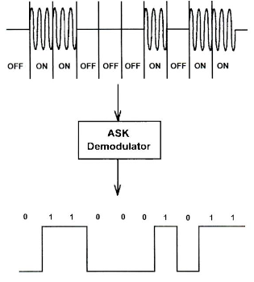

*Figure1.1. 6 Waveform of ASK Demodulated*

# Procedure and data analysis

## Part One: Amplitude shift keying Modulation (Time domain)

**The first part of the experiment aims to study and analyze the time-domain characteristics of Amplitude Shift Keying(ASK) modulation, focusing on two keying methods: hard-keying and soft-keying.**

### Hard keying:

The circuit of part#1 was connected as follow:

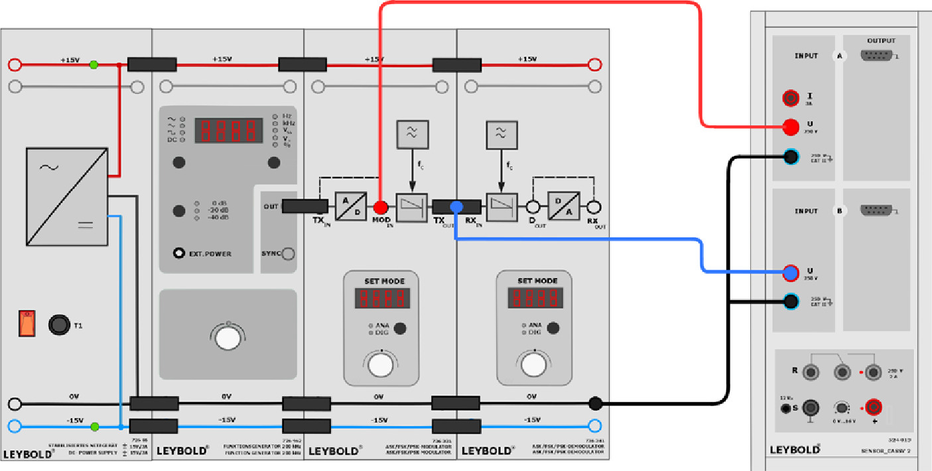

*Figure2.1. 1 Hard keying ASK circuit*

Before delving into the exploration of Amplitude Shift Keying (ASK), we need to configure the function generator. We'll start with a classic square wave, humming along at 1000 Hz with a robust 10-volt peak-to-peak amplitude. The on and off durations will share the stage equally, with a comfortable 50% duty-cycle. Next, we'll flip the switch to "Digital" mode, opening the door for modulation magic, and we'll crank up the modulation index to 100%.



* + - waveforms of output :

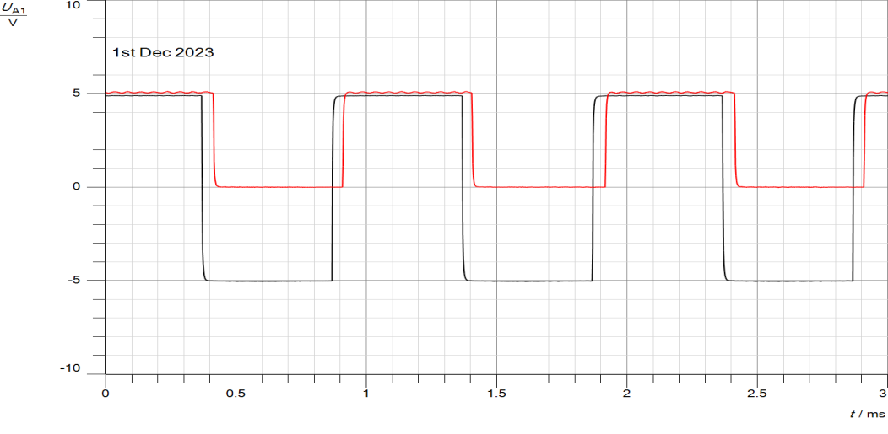

*Figure2.1. 2 Time-Domain Waveforms of Hard-Keyed ASK modulaton Signal with 100% Modulation Index*

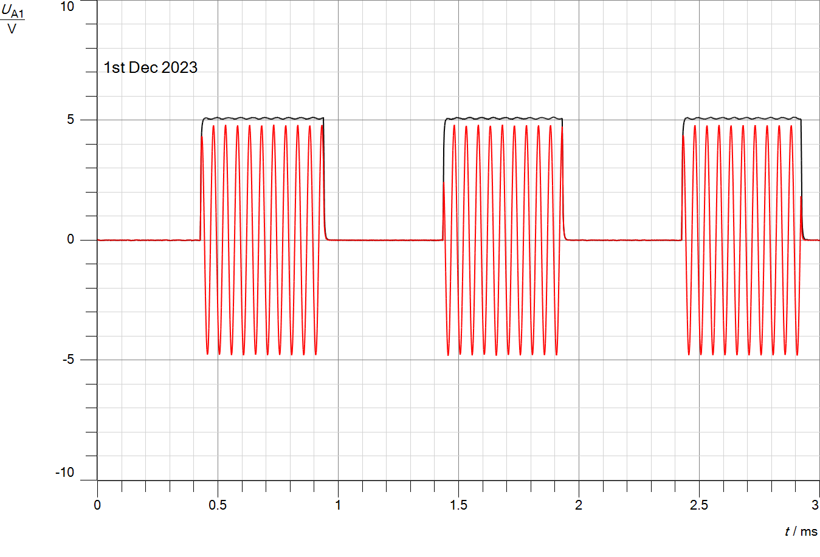

*Figure2.1. 3 Time-Domain Waveforms of Hard-Keyed ASK Modulated Signal at TXOUT(A11)*

As shown in figures above, the observations indicate the successful implementation of ASK modulation with hard keying, showcasing the impact on signal amplitude and providing a visual representation of the modulation process.

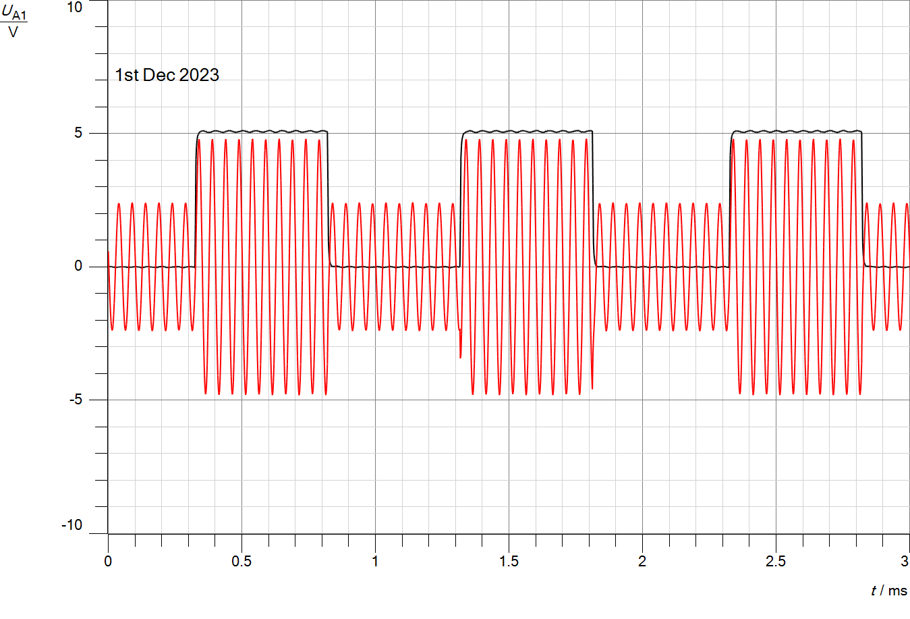

*Figure2.1. 4 ASK Modulated Signal with Hard Keying (m = 50%)*

Repeating the ASK modulation with hard keying and a modulation index of 50% showcased a different amplitude behavior, providing insights into how modulation index adjustments influence the characteristics of the modulated signal.

### Soft keying:

The circuit of Soft-Keying was connected as follow:



*Figure2.1. 5 Soft keying ASK circuit*

* + - waveforms of output :

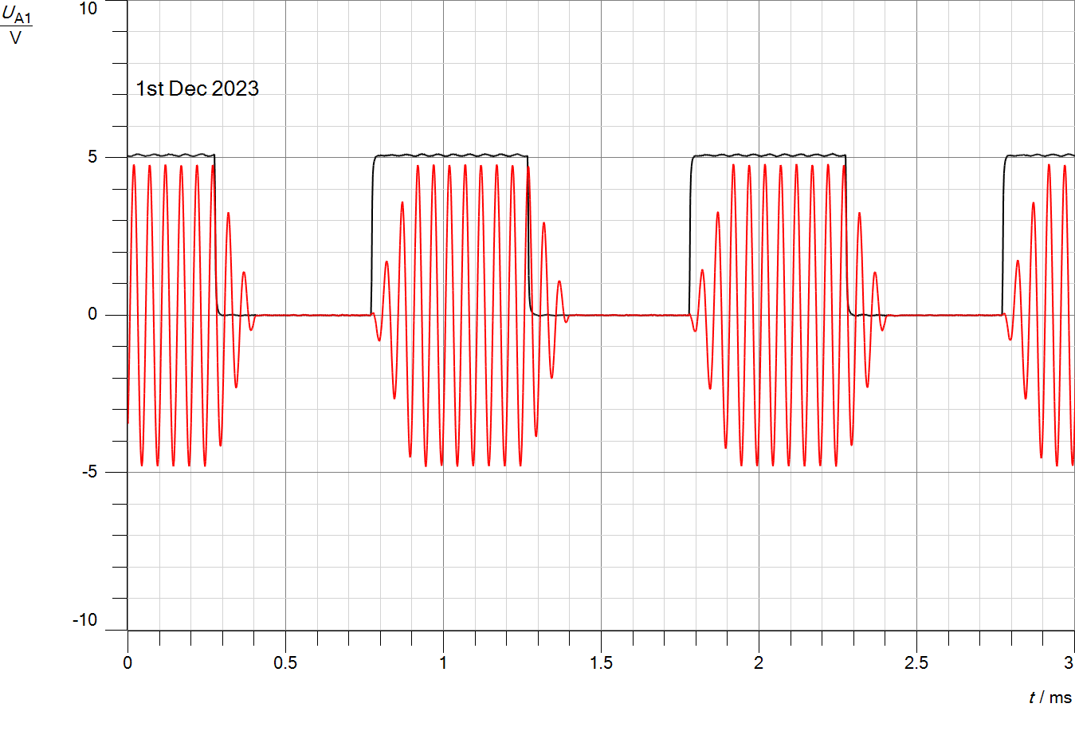

*Figure2.1. 6 Soft-Keyed ASK modulaton Signal with 100% Modulation Index*

The observations of the ASK modulation with soft-keying and a modulation-index of 100% (A12) revealed smoother amplitude transitions compared to hard keying. This provides insights into the impact of modulation techniques on the characteristics of the modulated signal.

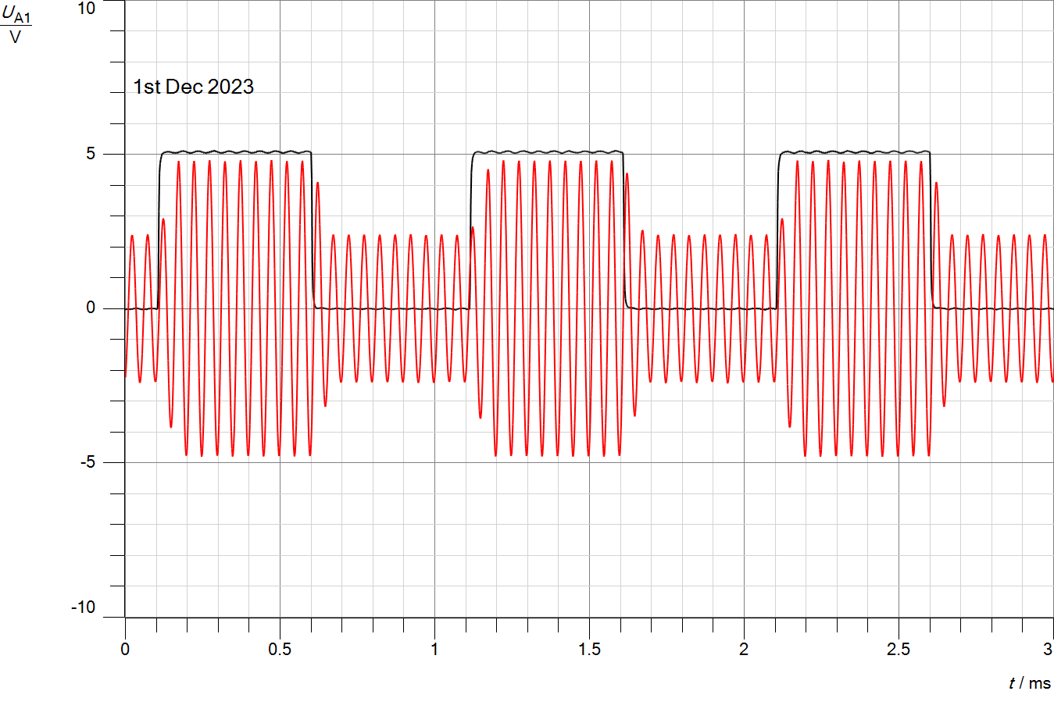

*Figure2.1. 7 Soft-Keyed ASK modulaton Signal with 50% Modulation Index*

The observations of ASK modulation with soft keying and a modulation index of 50% (A22) revealed intermediate amplitude transitions, providing a comprehensive understanding of how different modulation indices impact the characteristics of the modulated signal.

Note that they are similarities between (AM) and (ASK), as both are modulation techniques that involve varying the amplitude of a carrier signal to transmit information, like Amplitude Variation and Frequency Spectrum

### Detecting the comparator threshold:

In this section, we aim to identify the two thresholds, upper and lower, responsible for switching the ASK signal between its high and low amplitudes. To do this, we'll maintain the same connections used in the earlier parts of the experiment. The function generator is adjusted to produce a DC signal with a voltage (V) set to 0V. We then select Amplitude Shift Keying - Hard keying with a modulation index of 100% (A_11). Initiating the measurement, we gradually increase the DC value until reaching the high level of the ASK signal. This step is crucial for understanding the thresholds that trigger the transitions in amplitude within the ASK signal.

* + - waveforms of output :

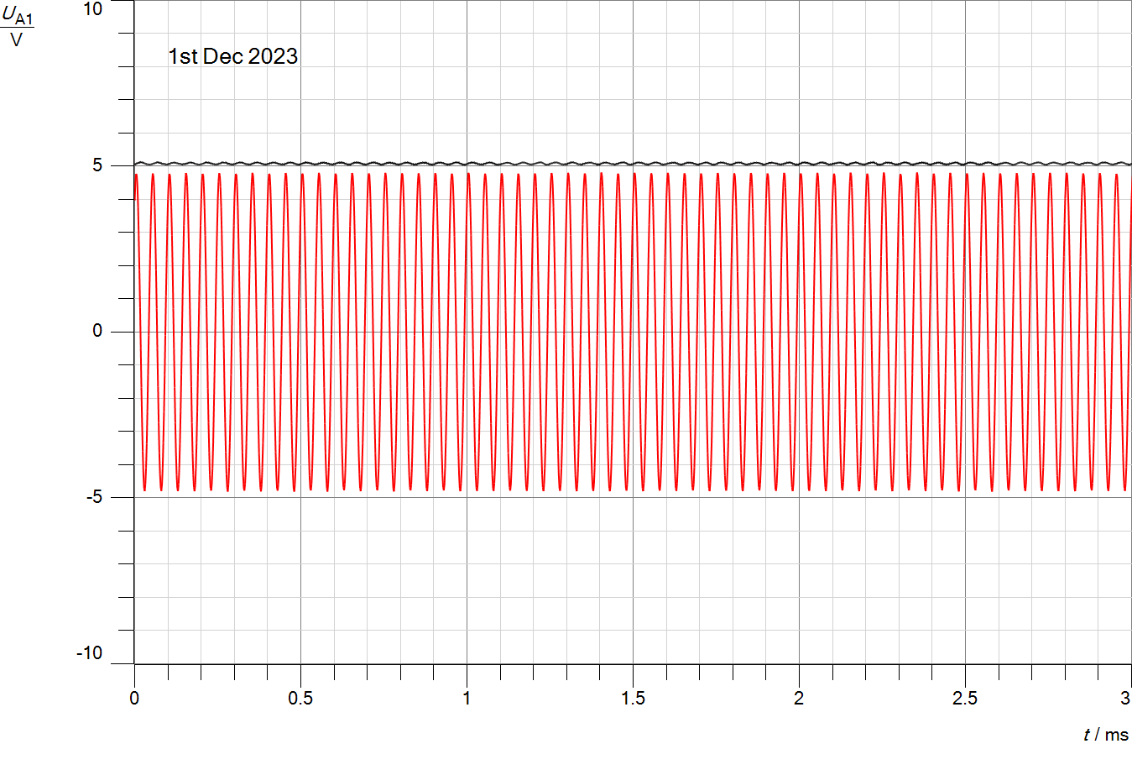

*Figure2.1. 8 High-Level Appearance in ASK Signal at Lower Threshold*

Gradually raise the DC-value during the measurement until the high level of the ASK signal emerges. The recorded DCaupper-threshold-value is=2.3.

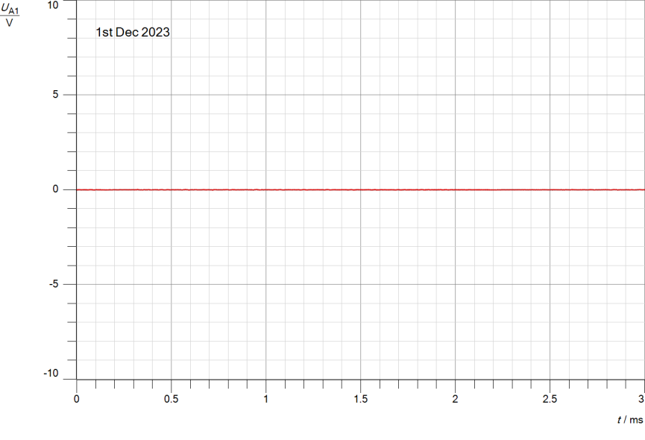

*Figure2.1. 9 Low-Level Appearance in ASK Signal at Upper Threshold*

Decrease the value gradually from 2.5V until the low-level (zero-volts) becomes visible on the ASK output-signal. The recorded DC lower-threshold-value is=1.67.

## Part Two: Amplitude shift keying Modulation (Frequency domain)

The second part of the experiment involves examining how the signal behaves across different frequencies. For this, the Cassy Lab is set in FFT-mode. The existing connections used in the previous parts. Cassy sensor-UA1 is connected to the ASK-signal at the outputiTXOUT of the modulator. The function generator is configured to produce a square wave with a frequency of 1000 Hz, a voltage swing (Vss) of 10V, and a duty-cycle of 50%.

### Hard keying:

* FFT when ASK-HardIkeying with modulationIindex= 100%(A11).

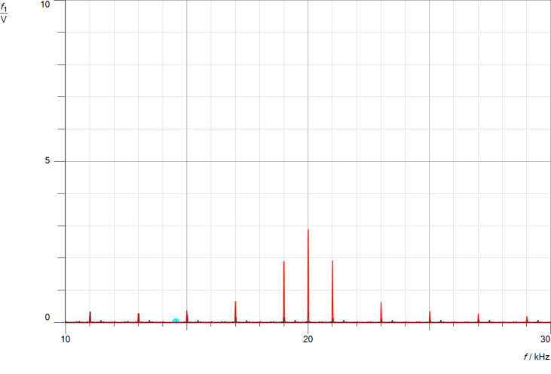

*Figure2.2. 1 Hard-Keyed ASK Spectrum with m=100% (FFT Analysis)*

* FFT when ASK-HardIkeying with modulationIindex= 50%(A21).

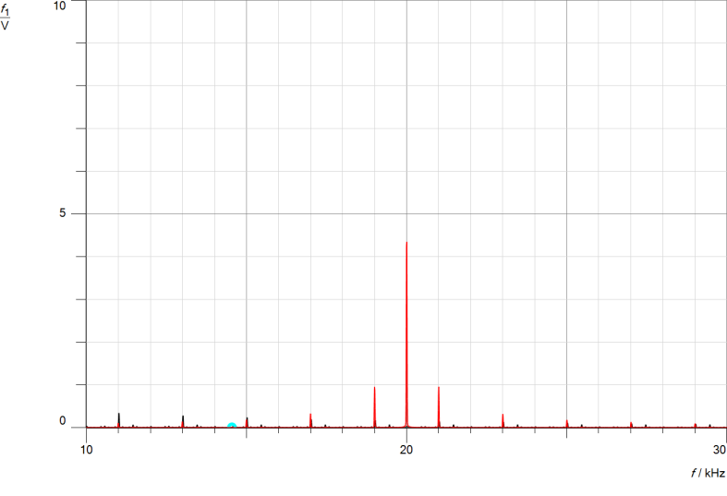

*Figure2.2. 2 Hard-Keyed ASK Spectrum with m=50% (FFT Analysis)*

Note, in hard keying with a modulation index of 50%, the carrier-signal remains constant, and the spectrum-impulses are still well-separated and exhibit lower amplitudes compared to the modulation-index of 100%. These impulses represent the distinct frequency components present in the ASK-signal.

### Soft keying:

* FFT when ASK-SoftIkeying with modulationIindex= 100%(A12).

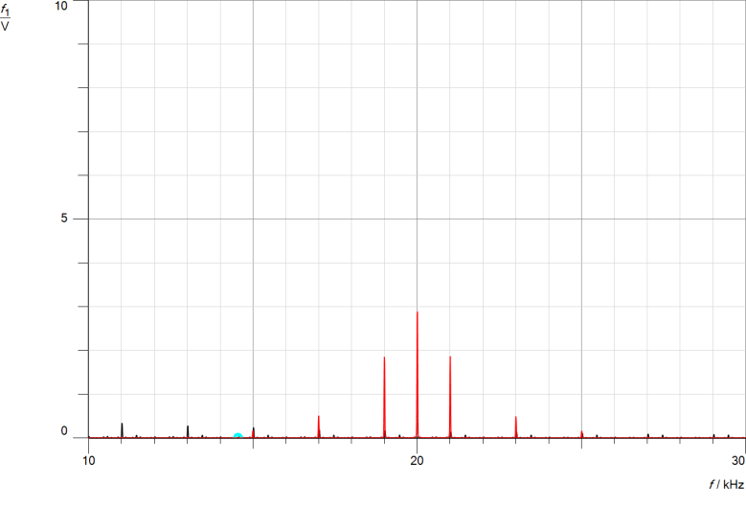

*Figure2.2. 3 Soft-Keyed ASK Spectrum with m=100% (FFT Analysis)*

* FFT when ASK-SoftIkeying with modulationIindex= 50%(A22).

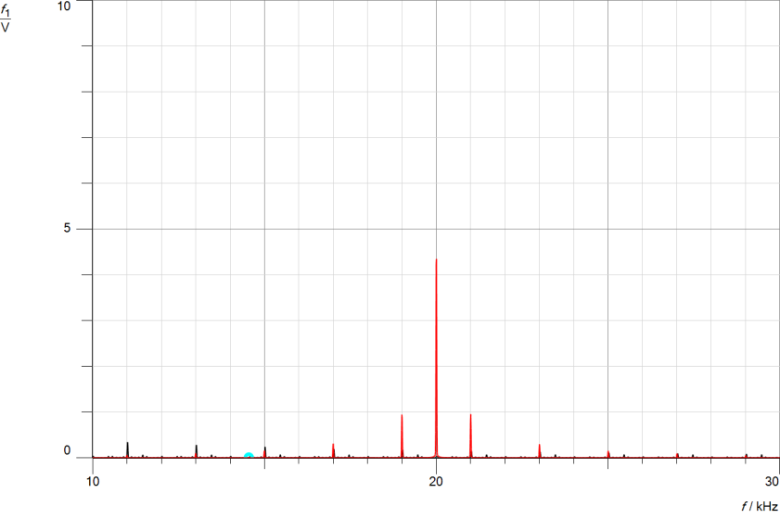

*Figure2.2. 4 Soft-Keyed ASK Spectrum with m=50% (FFT Analysis)*

### Studying the effect of changing the message signal amplitude (Time and frequency domains):

In the time-domain and Freq-domain, the demodulated-signal of ASK with modulation-index of (A11&12).

### https://lh7-us.googleusercontent.com/ADv1V6OuSBDsZBtNBiMiXFqcUlxL4Vl6aWN8Jp8FiSizFDVpMLqhbUVOMMgJry9VvV7uQwfe3-b9v_pUaNclSjHpCHPK1VEGEpByJLoOqBrHvcyL00_tSKZPfW9WvJRNPK7Df8R4UMXxeUWNwBpDQw

*Figure2.2. 5 Time-Domain Impact of Message Amplitude Reduction on ASK(A11&A12)*

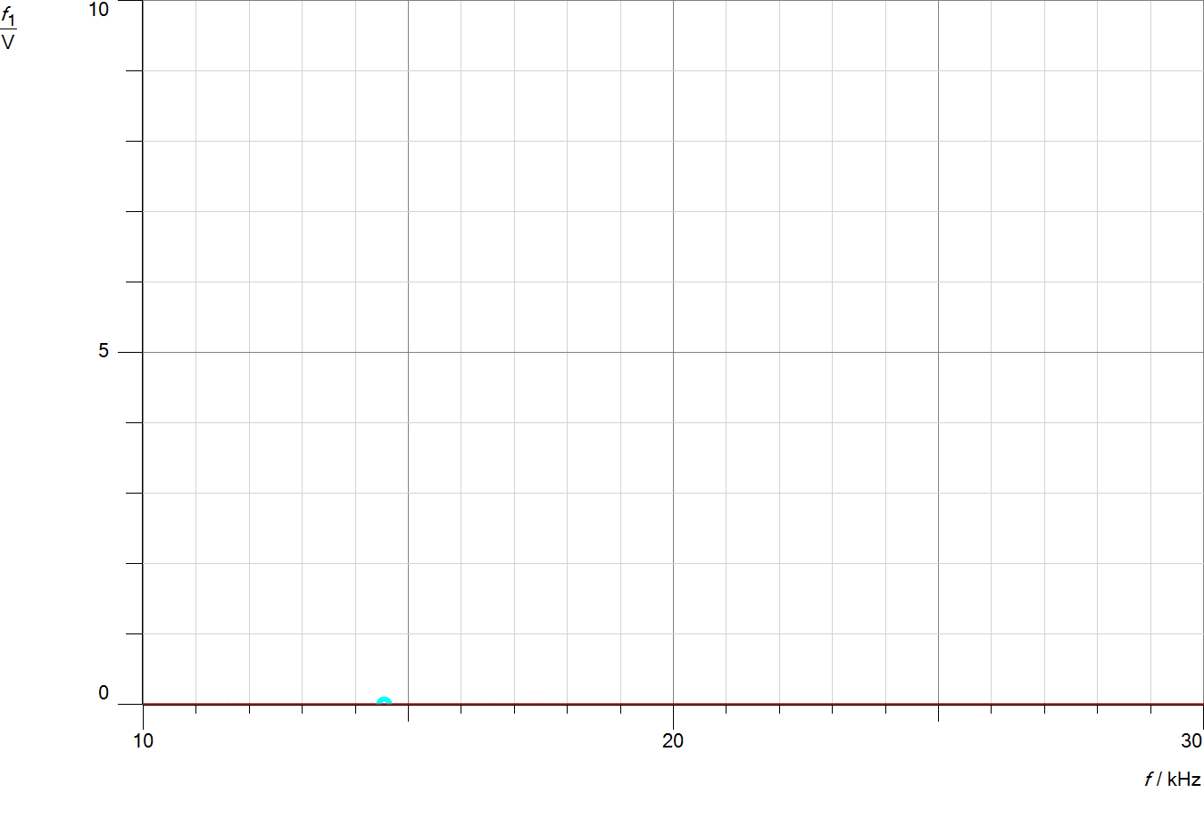

*Figure2.2. 6 Freq-Domain Impact of Message Amplitude Reduction on ASK(A11&A12)*

In the time-domain and Freq-domain, the demodulated-signal of ASK with modulation-index of (A21&A22).

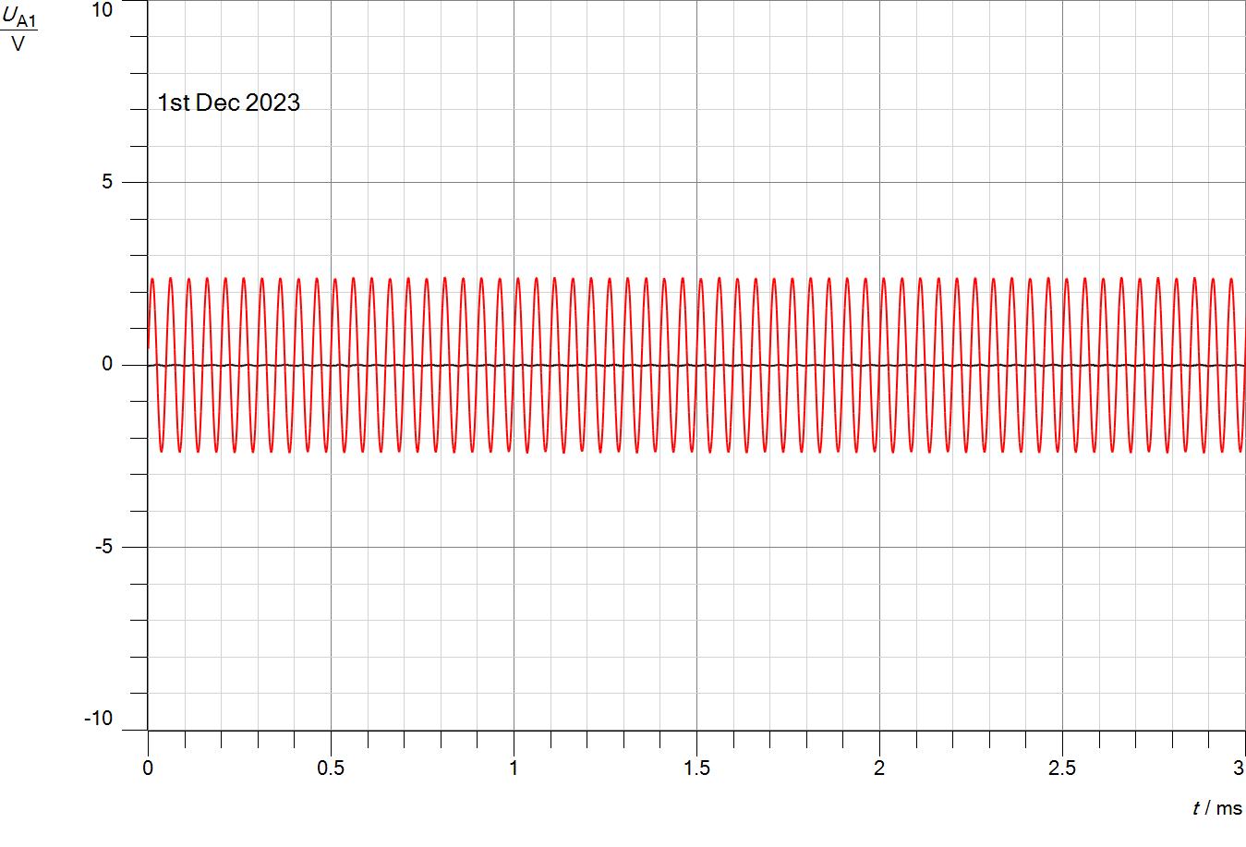

*Figure2.2. 7 Time-Domain Impact of Message Amplitude Reduction on ASK(A21&A22)*

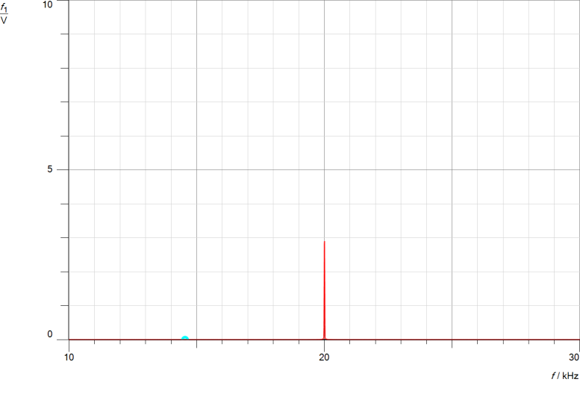

*Figure2.2. 8 Freq-Domain Impact of Message Amplitude on ASK(A21/A22)*

### Studying the effect of changing the message signal frequency on (Time and frequency domains):

In the time-domain and Freq-domain, the demodulated-signal of ASK with modulation-index of (A11).

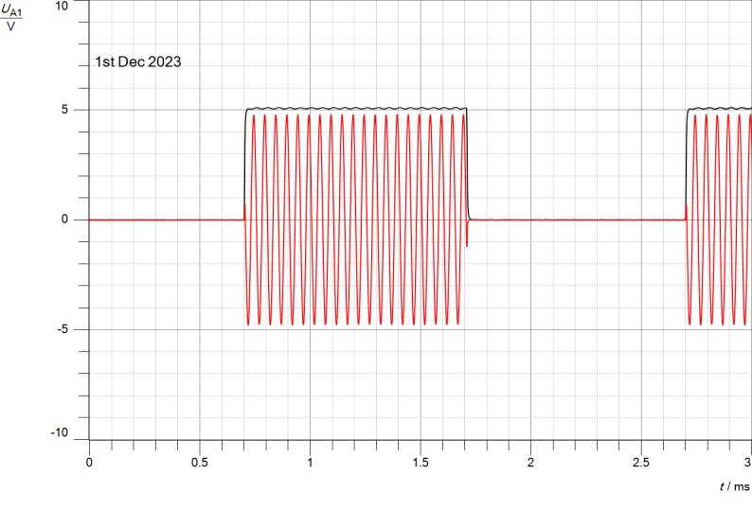

*Figure2.2. 9 Time-Domain Impact of Message frequency on ASK(A11)*

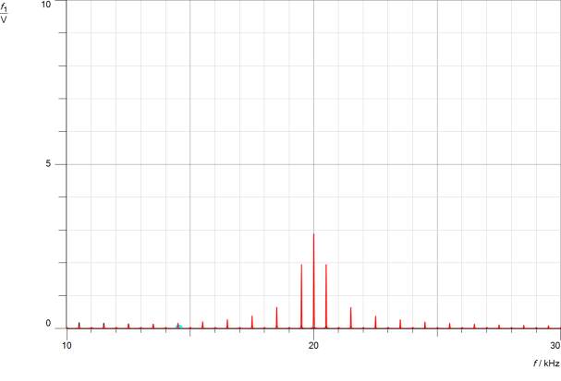

*Figure2.2. 10 Freq-Domain Impact of Message frequency on ASK(A11)*

In the time-domain and Freq-domain, the demodulated-signal of ASK with modulation-index of (A12).

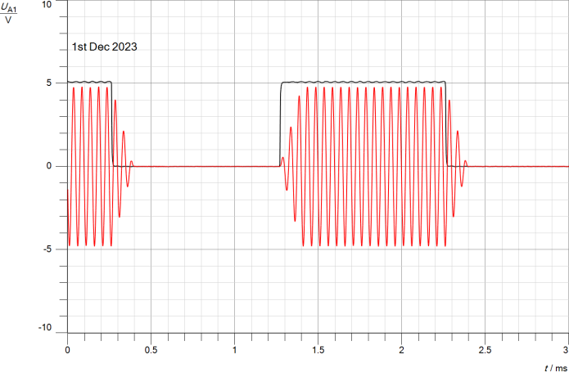

*Figure2.2. 11 Time-Domain Impact of Message frequency on ASK(A12)*

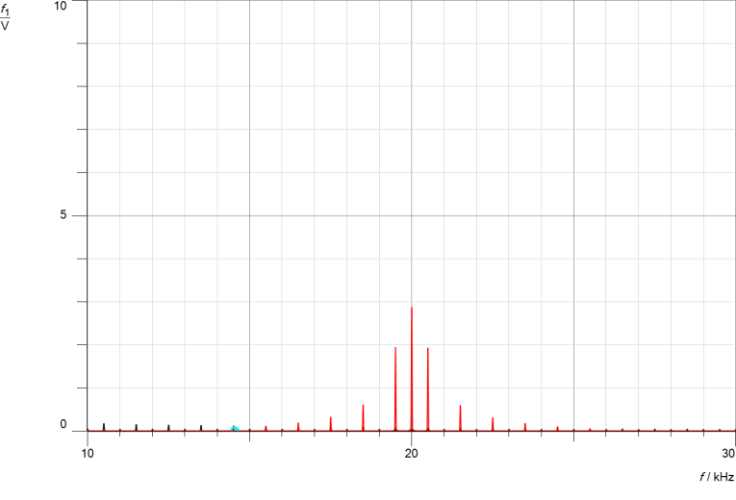

*Figure2.2. 12 Freq-Domain Impact of Message frequency on ASK(A12)*

In the time-domain and Freq-domain, the demodulated-signal of ASK with modulation-index of (A21).

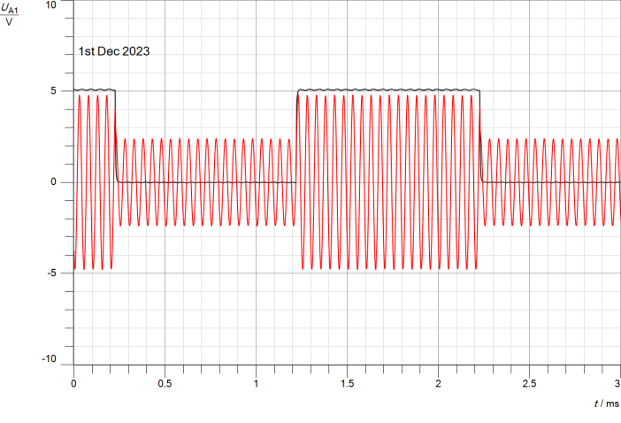

*Figure2.2. 13 Time-Domain Impact of Message frequency on ASK(A21)*

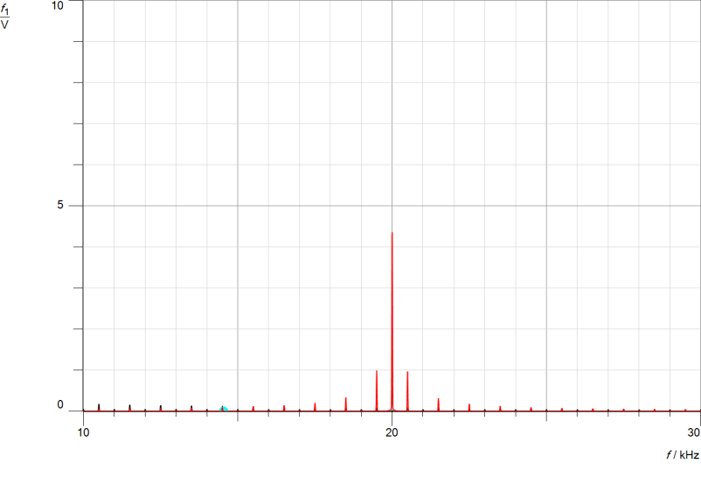

*Figure2.2. 14 Freq-Domain Impact of Message frequency on ASK(A21)*

In the time-domain and Freq-domain, the demodulated-signal of ASK with modulation-index of (A22).

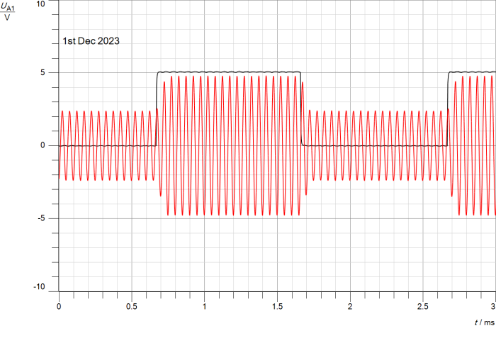

*Figure2.2. 15 Time-Domain Impact of Message frequency on ASK(A22)*

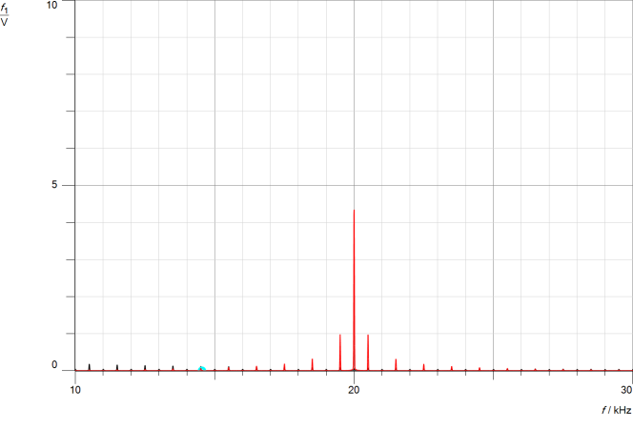

*Figure2.2. 16 Freq-Domain Impact of Message frequency on ASK(A22)*

### Studying the effect of changing the message signal duty cycle (Time and frequency domains):

In the time-domain and Freq-domain, the demodulated-signal of ASK with modulation-index of (A11).

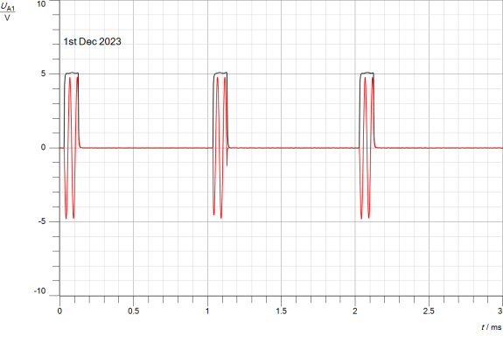

*Figure2.2. 17 Time-Domain Impact of Message duty-cycle on ASK(A11)*

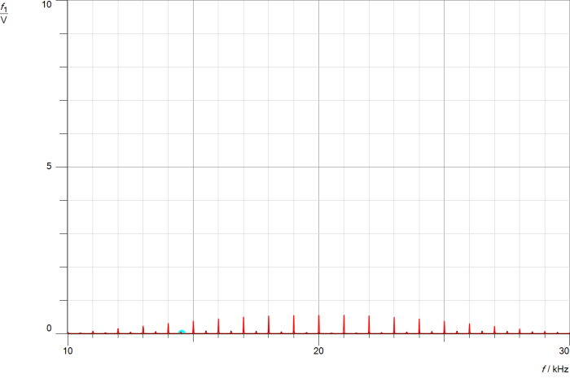

*Figure2.2. 18 Freq-Domain Impact of Message duty-cycle on ASK(A11)*

In the time-domain and Freq-domain, the demodulated-signal of ASK with modulation-index of (A12).

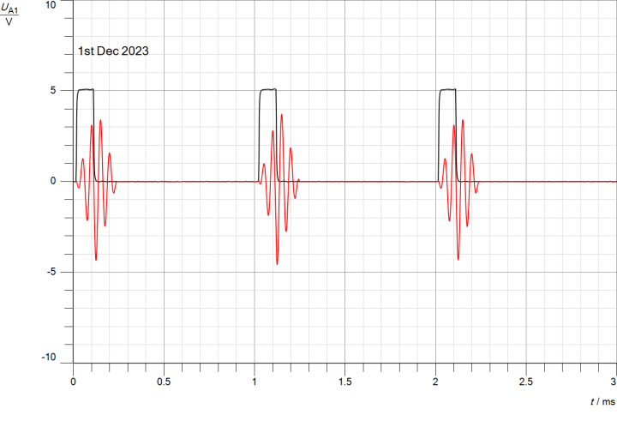

*Figure2.2. 19 Time-Domain Impact of Message duty-cycle on ASK(A12)*

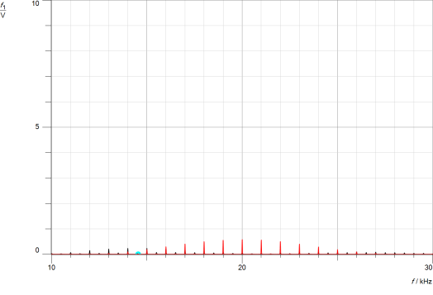

*Figure2.2. 20 Freq-Domain Impact of Message duty-cycle on ASK(A12)*

In the time-domain and Freq-domain, the demodulated-signal of ASK with modulation-index of (A21).

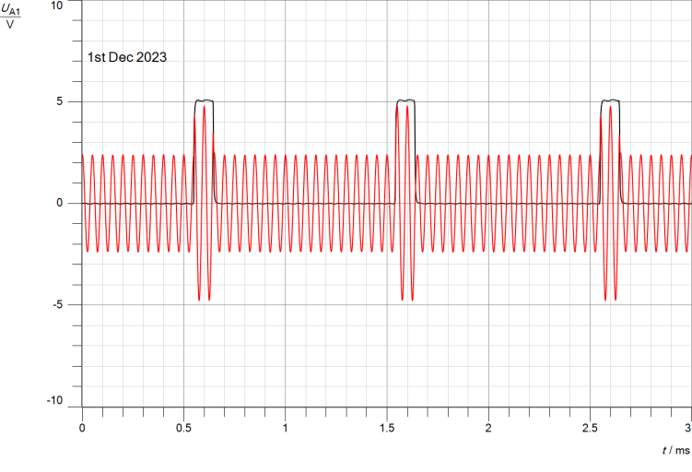

*Figure2.2. 21 Time-Domain Impact of Message duty-cycle on ASK(A21)*

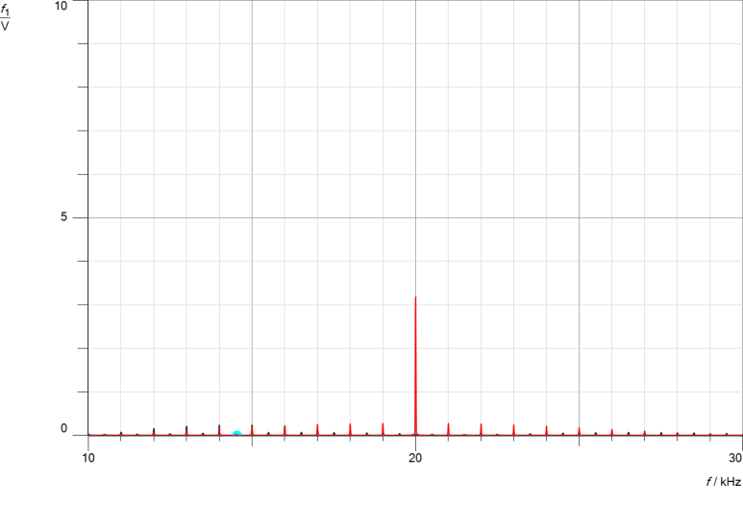

*Figure2.2. 22 Freq-Domain Impact of Message duty-cycle on ASK(A21)*

In the time-domain and Freq-domain, the demodulated-signal of ASK with modulation-index of (A22).

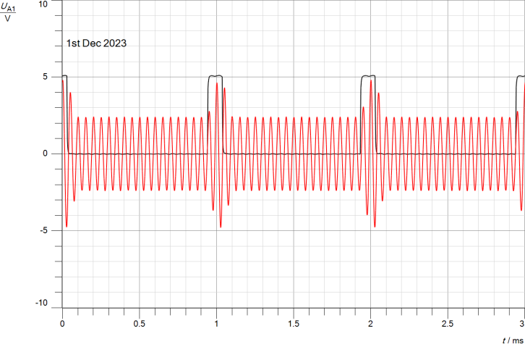

*Figure2. 23 Time-Domain Impact of Message duty-cycle on ASK(A22)*

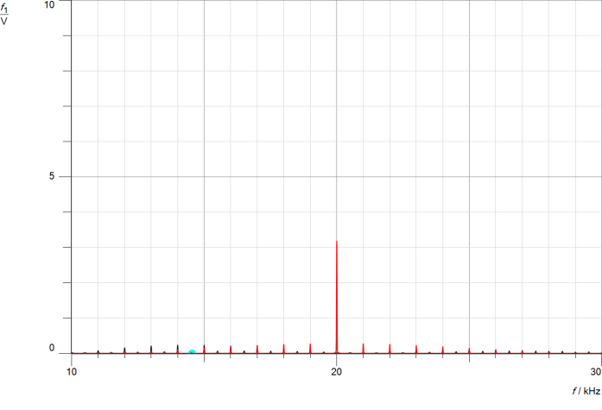

*Figure2.2. 24 Freq-Domain Impact of Message duty-cycle on ASK(A22)*

## Part Three: Amplitude shift keying Demodulation (Time and frequency domains)

In this part of **experiment aims to study and analyze the time-domain and Freq-domain characteristics of Amplitude Shift Keying(ASK) demodulation, focusing on two keying methods: hard-keying and soft-keying.**

The circuit of part#3 was connected as follow:



*Figure2.3. 1 ASK Demodulation circuit*

The setup involves adjusting the function generator parameters to produce a square wave with a frequency of 1000 Hz, a voltage swing of 10V, and a duty cycle of 50%. The demodulator is set to Digital (DIG) mode with a selected demodulation type (A). The Cassy sensors UA1 and UB1 are strategically connected to capture the bipolar message square-wave signal at MODIN and the demodulated signal at the output RXOUT, respectively. This configuration allows for the investigation of demodulation processes and signal characteristics in both the time and frequency domains.

### Hard keying:

In the time-domain and Freq-domain, the demodulated signal of Amplitude Shift Keying (ASK) with Hard Keying and a modulation index of 100% (A11)

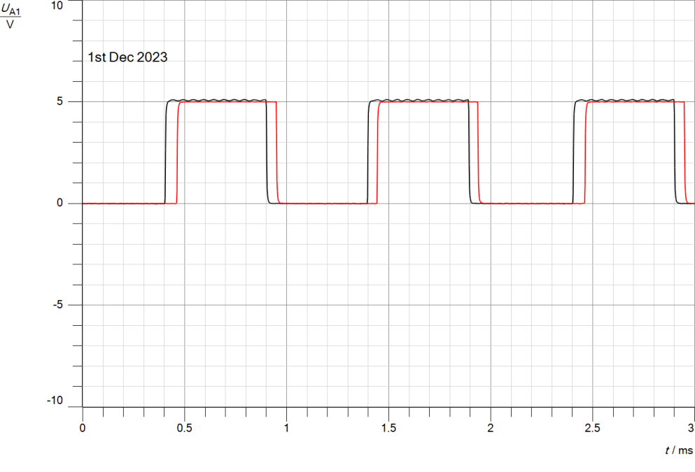

*Figure2.3. 2 ASK DeModulated Signal with Hard Keying (m = 100%)(Time-Domain)*

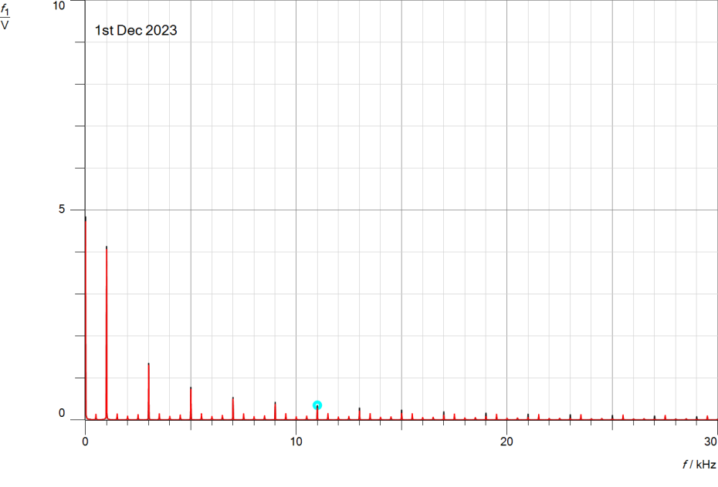

*Figure2.3. 3 ASK DeModulated Signal with Hard Keying (m = 100%)(Freq-Domain)*

In the time-domain and Freq-domain, the demodulated signal of Amplitude Shift Keying (ASK) with Hard Keying and a modulation index of 50% (A21)

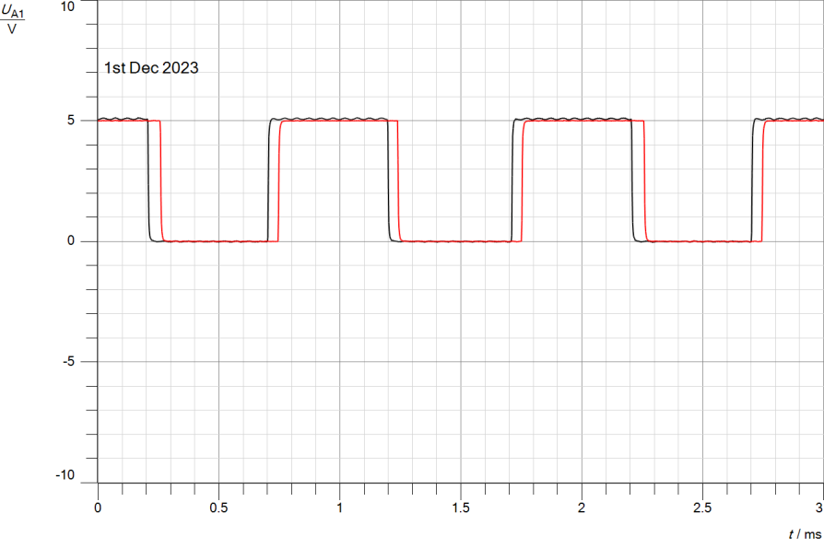

*Figure2.3. 4 ASK DeModulated Signal with Hard Keying (m = 50%)(Time-Domain)*

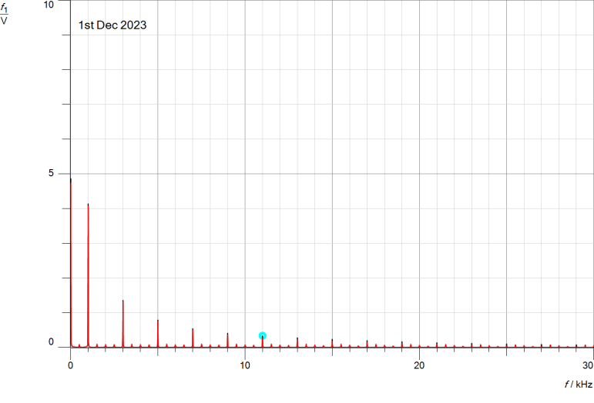

*Figure2.3. 5 ASK DeModulated Signal with Hard Keying (m = 50%)(freq-Domain)*

### Soft keying:

In the time-domain and Freq-domain, the demodulated signal of Amplitude-Shift-Keying(ASK) with Soft-Keying and a modulation-index of 100% (A12)

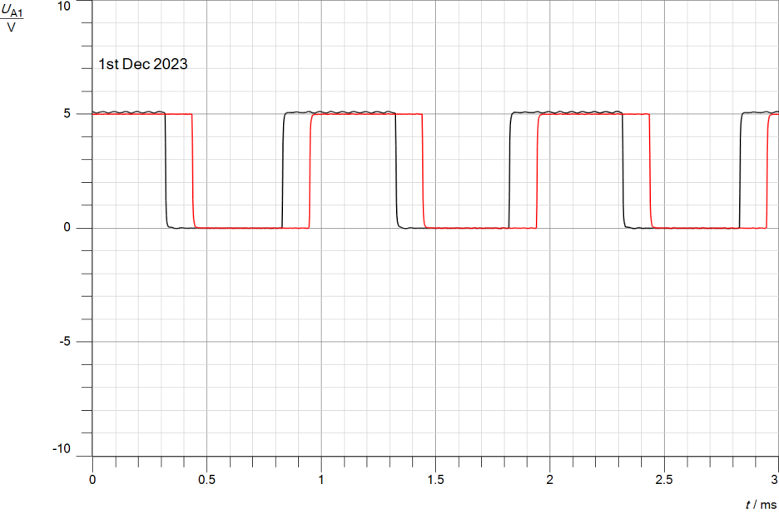

*Figure2.3. 6 ASK DeModulated Signal with Soft-Keying (m = 100%)(Time-Domain)*

### https://lh7-us.googleusercontent.com/ETfM6niPss9NfdmiVKAuqA6aiVsWt5wRz_t4etnuwv3PHEWvU_tj_uAO1mmSpYz76_SYManm58s-eJb6DhW0cjHiL_XawquSp4m74lvggHqgWjjNJXxI1NIefaNZBk12RKl757ORJd7HR0kd_4UE8g

*Figure2.3. 7 ASK DeModulated Signal with Soft-Keying (m = 100%)(Freq-Domain)*

In the time-domain and Freq-domain, the demodulated-signal of Amplitude-Shift-Keying(ASK) with Soft-Keying and a modulation-index of 50% (A22).

### https://lh7-us.googleusercontent.com/thlvJlYHs_Le8rvRDxnO8Nrlt4MvdoyMbeIw5QbGeAH9InOsQEJycLgb_b0hvp5O57TwKc74lMgh0QNTre1Aerb2TR9FakXRnZ0Elppl6ILpZNf0hVfji38uyzBKhbv78E4HxW_HwXjoLmrJa-apgg

*Figure2.3. 8 ASK DeModulated Signal with Soft-Keying (m = 50%)(Time-Domain)*

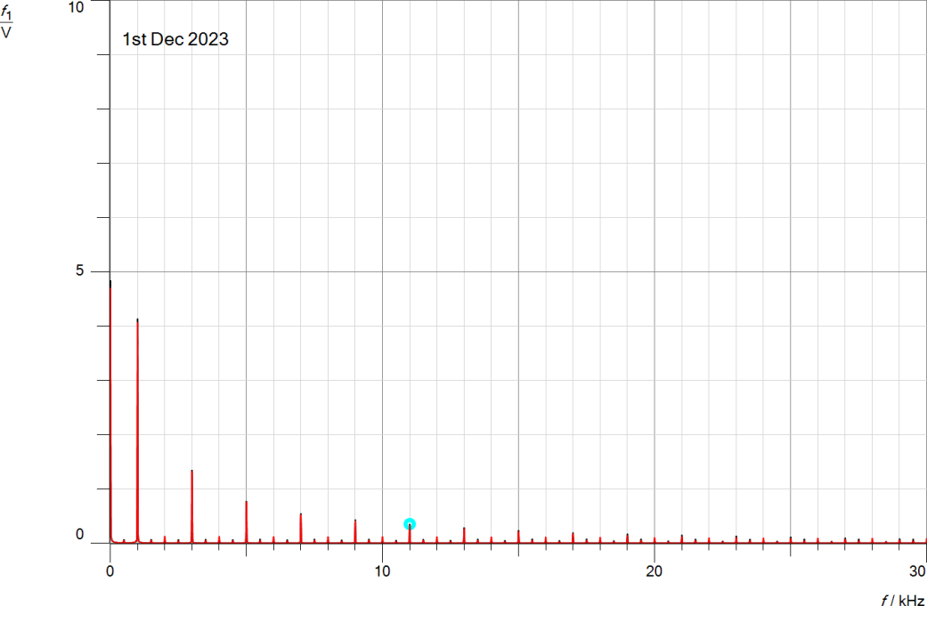*Figure2.3. 9 ASK DeModulated Signal with Soft-Keying (m = 50%)(freq-Domain)*

### Studying the effect of changing the message signal frequency on the demodulation:

Connections the function-generator to produce a square-wave with a frequency of 500 Hz, Vss of 10V, and a duty cycle of 50%, while connecting Cassy sensor UA1 to the bipolar message square-wave signal at TXIN.

In the time-domain and Freq-domain, the demodulated-signal of ASK with modulation-index of 100% (A11).

### https://lh7-us.googleusercontent.com/NB16XTUAeL1yjaZJZK300xa1ekdkGvW_eAyC7vKW_QrC53bSU8FILzHlgJvXkdJlkUN8eL63qyF5FrjELRBU8S6g9-zPu3vKga25PcFTse_KvJp6Dh6pWEHZiFnByV2nwFg-3KHT1yaWZYH8cZcUdQ

*Figure2.3. 10 Time-Domain Impact of Message frequency on Demodulation ASK(A11)*

### https://lh7-us.googleusercontent.com/VXEd7c3-OhBOYOGoUNFPj9JSHOzzqmh8E0aQ5zy495gBkPz_MTmYau-9hPKJM8q8ECCLGK69tbH5vEHx83sj_YEj-krDQqnl3CUSvliJ8b0m3BuBNrNOOzfdO5iKnJpMnBhQMYYO5DhODEzQurJptA

*Figure2.3. 11 Freq-Domain Impact of Message frequency on Demodulation ASK(A11)*

In the time-domain and Freq-domain, the demodulated-signal of ASK with modulation-index of (A12).

### https://lh7-us.googleusercontent.com/JNZjwidEqVjuXb_RmYgL9T4NX5v5BgufAkKJf28K6wIR-AHlR0K-GwWCFV210wqSAA6qFGOYfusHlRaiQS-Rhk_zEyS-QnNJ0Rhj02BRmBfPv9llLETfG4nSj6L1LZ5bAhXt_WxtzvpAIDqviNKmoA

*Figure2.3. 12 Time-Domain Impact of Message frequency on Demodulation ASK(A12)*

### https://lh7-us.googleusercontent.com/VKoHzBxnY_HAKDWxQ0TsOk5P9aSsirviDw8f29qtx1VyFmIHH1k9xl5FZOqfwwbi90Q4XOoKKJvedYAVSaTjmh-ydSWpTYh42ZuEDt8jTADx0vxpoT3Ntz_ryz2XcYIToIf-eJ2llAE7nfwlu3DJFA

*Figure2.3. 13 Freq-Domain Impact of Message frequency on Demodulation ASK(A12)*

In the time-domain and Freq-domain, the demodulated-signal of ASK with modulation-index of (A21).

### https://lh7-us.googleusercontent.com/8idU7TyPluF6ytPDeS4vSugkt6U7cseIa1YUaCFPWhMhZTnSOmZO2Ad73Hq5prhMcM2QT2XS79-IrzvEpgOlzqEXX7MK4_ftx2afNDcS9hPIit7XXhmRe4eF0w0S7-qh7W2SAL2UY12DG0RoY4rjGA

*Figure2.3. 14 Time-Domain Impact of Message frequency on Demodulation ASK(A21)*

### https://lh7-us.googleusercontent.com/tflYgXUHX2tpB43CwlFTiXhZPNHwOmjn_O0SwmpfLyQHDx7JUpVWXyY5ovB_bbpuFRWal_Vjss5GbxZ0cpUSvhceamOe_GPDALKIgOGLmKDdp0Wp-89dSH6oJ7jN0WsJE1MVs06k2zAA5ovb8wVobQ

*Figure2.3. 15 Freq-Domain Impact of Message frequency on Demodulation ASK(A21)*

In the time-domain and Freq-domain, the demodulated-signal of ASK with modulation-index of (A22).

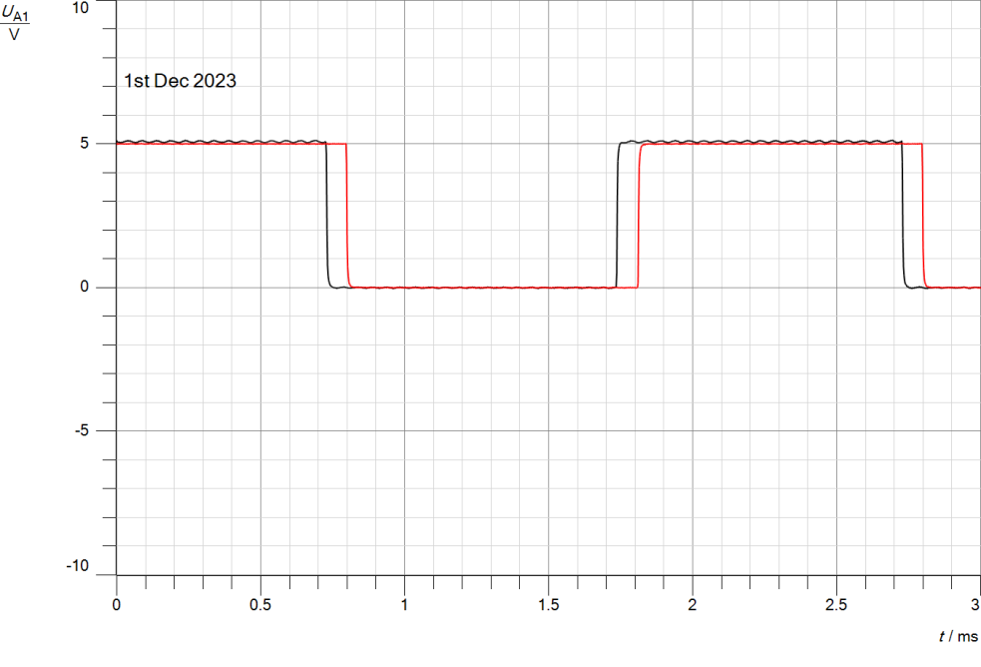

*Figure2.3. 16 Time-Domain Impact of Message frequency on Demodulation ASK(A22)*

### https://lh7-us.googleusercontent.com/h5XfKapGg72PDQ3elmtZCBvinlC-sERNOwW-fO6UQl2GO6uluTY0xE955NsGg1fUPBwduXOW2ggQGXHaRN62qqcqff2gpdPivd2gMOyvrdYHuKMC3W4R-evysf_NWBksEU-P5mv317yjdN4mqKEUPw

*Figure2.3. 17 Freq-Domain Impact of Message frequency on Demodulation ASK(A22)*

### Studying the effect of changing the message signal duty cycle on the demodulation:

Observing how changes in the duty cycle of the message signal affect demodulation includes keeping the same connections and adjusting the function generator to create a square-wave with a frequency of 1000 Hz, 10V amplitude, and a 10% duty cycle. By increasing the duty-cycle, we can learn more about its impact on (ASK) demodulation.

In the time-domain and Freq-domain, the demodulated-signal of ASK with modulation-index of (A11).

### https://lh7-us.googleusercontent.com/OcxOHw2xbwPQOSz_wBhyerRZtov-f8AS_1dboj6WgQMq2zDO1GKOpUwpncu9_0-7j9SyC35FY5Kg43yBQ11_liwO76i-L4qb4EENDL5qAARXJwtZ93YsgU6umFZRdX_umq5zFOjfNZVkzo9eEPRvmQ

*Figure2.3. 18 Time-Domain Impact of Message duty-cycle on Demodulation ASK(A11)*

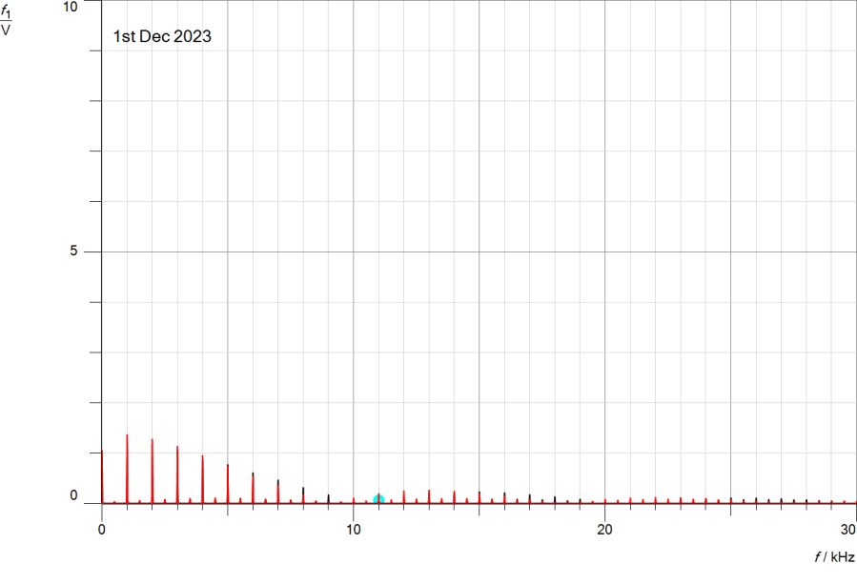

*Figure2.3. 19 Freq-Domain Impact of Message duty-cycle on Demodulation ASK(A11)*

In the time-domain and Freq-domain, the demodulated-signal of ASK with modulation-index of (A12).

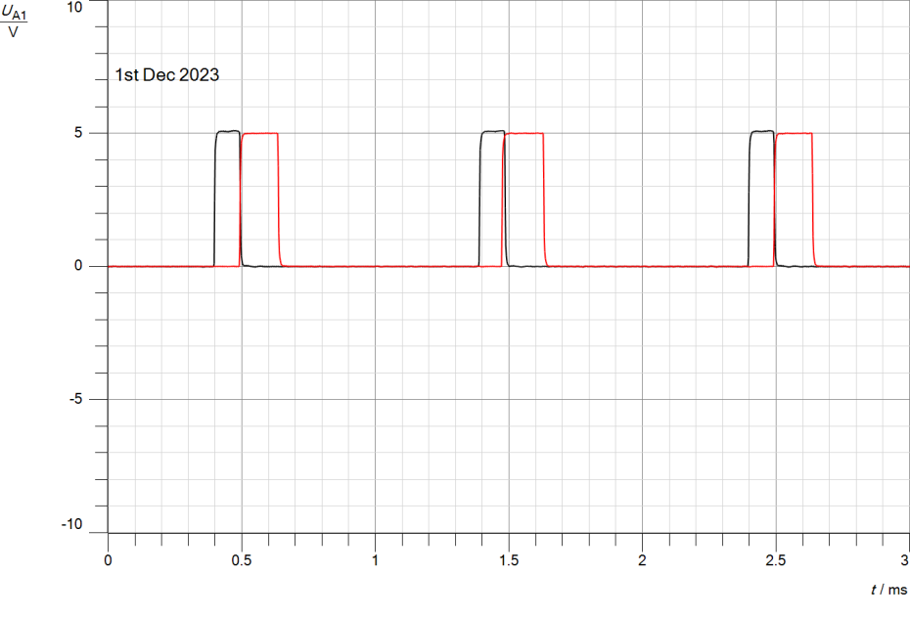

*Figure2.3. 20 Time-Domain Impact of Message duty-cycle on Demodulation ASK(A12)*

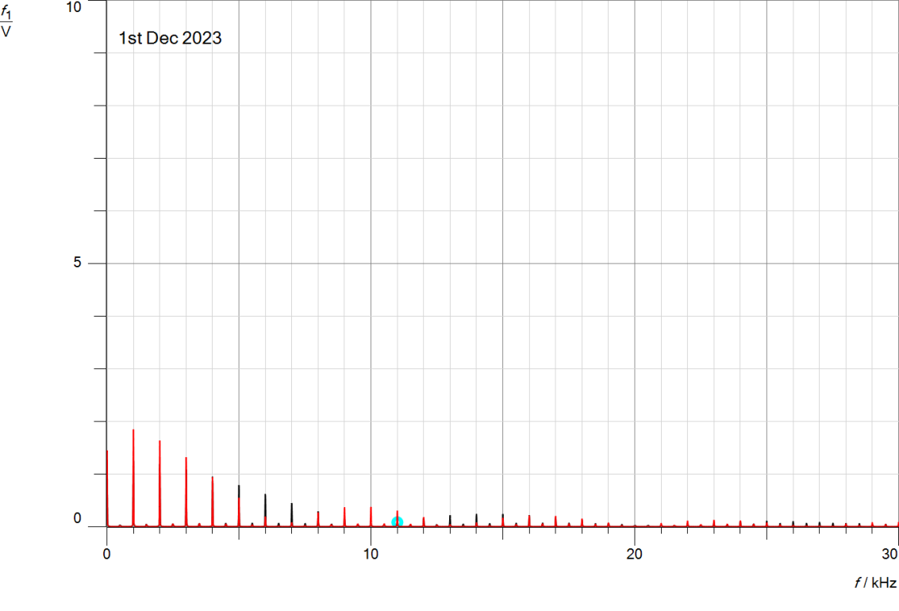

*Figure2.3. 21 Freq-Domain Impact of Message duty-cycle on Demodulation ASK(A12)*

In the time-domain and Freq-domain, the demodulated-signal of ASK with modulation-index of (A21).

### https://lh7-us.googleusercontent.com/6we6q4j1moDB5Jd_als4BEdK0GPIHHyOOkXDtP7nMS5HdxYEWE50FBVH9Px44XXv1vWnVhiPo5C64puMlJqvF1nYr06xdl3lsu6p-B3Io8uPRxP92gcmF1UIsTrldiUUsWEJhxaq27Guu3VsSi1l3A

*Figure2.3. 22 Time-Domain Impact of Message duty-cycle on Demodulation ASK(A21)*

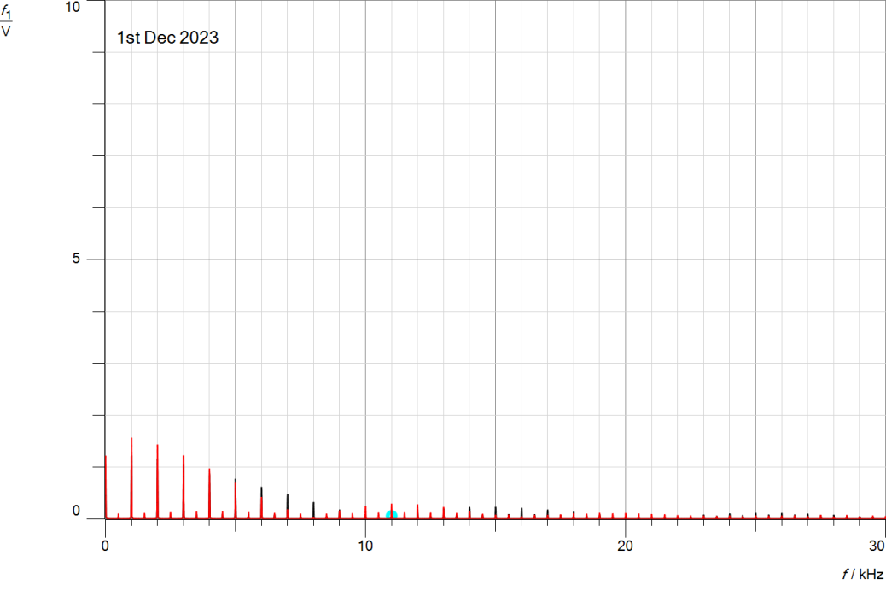

*Figure2.3. 23 Freq-Domain Impact of Message duty-cycle on Demodulation ASK(A21)*

In the time-domain and Freq-domain, the demodulated-signal of ASK with modulation-index of (A22).

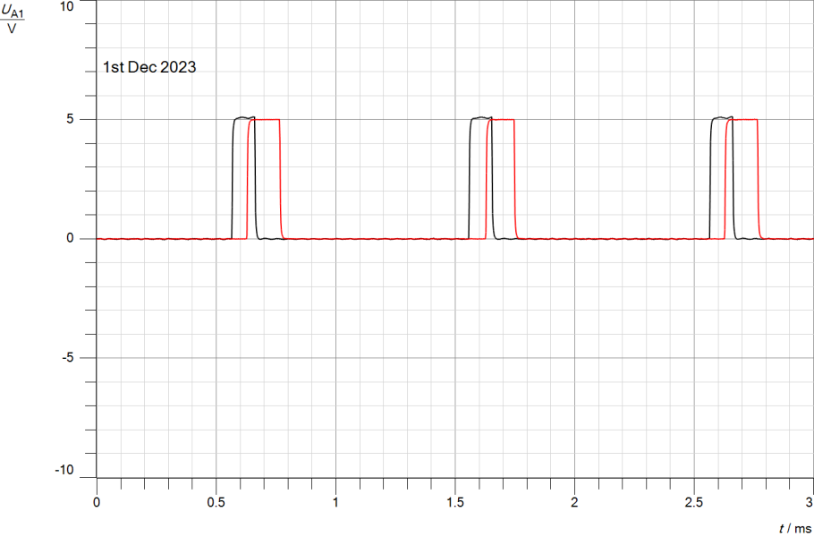

*Figure2.3. 24 Time-Domain Impact of Message duty-cycle on Demodulation ASK(A22)*

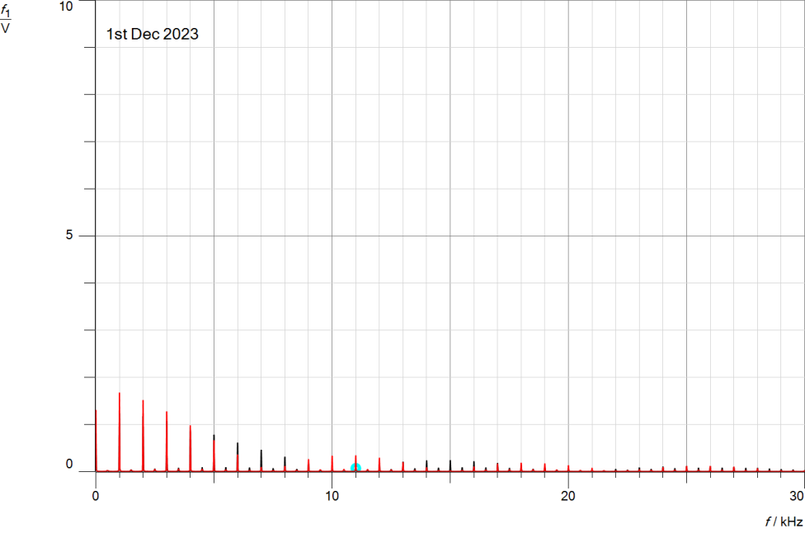

*Figure2.3. 25 Freq-Domain Impact of Message frequency on Demodulation ASK(A22)*

# Conclusion

In conclusion, this experiment has provided a comprehensive exploration of ASK modulation and demodulation in both the time and frequency domains. The concepts of hard and soft keying modulation techniques were elucidated. The analysis extended to the frequency domain, revealing the impact of changing message signal parameters on temporal and spectral characteristics. In addition, the study included demodulation techniques, both hard and soft keying, highlighting the significance of message signal frequency and duty cycle in accurate signal recovery. Overall, this experiment not only clarified the foundational principles of ASK systems but also offered practical insights for optimizing their performance in real-world applications.

# References

1. [https://www.geeksforgeeks.org/amplitude-shift-keying/](https://en.wikipedia.org/wiki/Phase_modulation) [Accessed on 16-1-2024 at 8:33 PM].
2. <https://www.tutorialspoint.com/principles_of_communication/principles_of_communication_amplitude_modulation.htm> [Accessed on 17-1-2024 at 2:14 AM].
3. <https://www.uoanbar.edu.iq/eStoreImages/Bank/4073.pdf> [Accessed on 17-1-2024 at 6:4 AM].
4. Communication system slides.

